HbA₁c  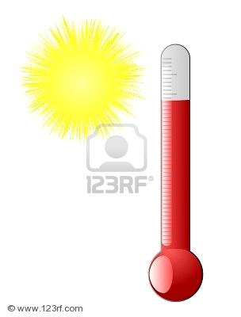  % |  | HbA₁c  mmol/mol | Glicemia media  mg/dL

13 |  | 119 | 326
12 |  | 108 | 298
11 |  | 97 | 269
10 |  | 86 | 240
9 |  | 75 | 212
8 |  | 64 | 183
7 |  | 53 | 154
6 |  | 42 | 126
5 |  | 31 | 97
4 |  | 20 | 68

